Analysis and Conclusion

Project 1 – Group 11

Tourism is a huge global industry and tends to correlate with how well countries perform economically. We decided to research if inbound tourists and tourism receipts had any correlation with the GDP of a country. To do so we asked ourselves these four questions:

1. Which country had the most inbound tourists?

2. Which country had the highest tourism receipts?

3. Which country had the highest GDP?

4. What is the correlation?

Our findings are as follows.

Question 1: Which country had the most inbound tourists?

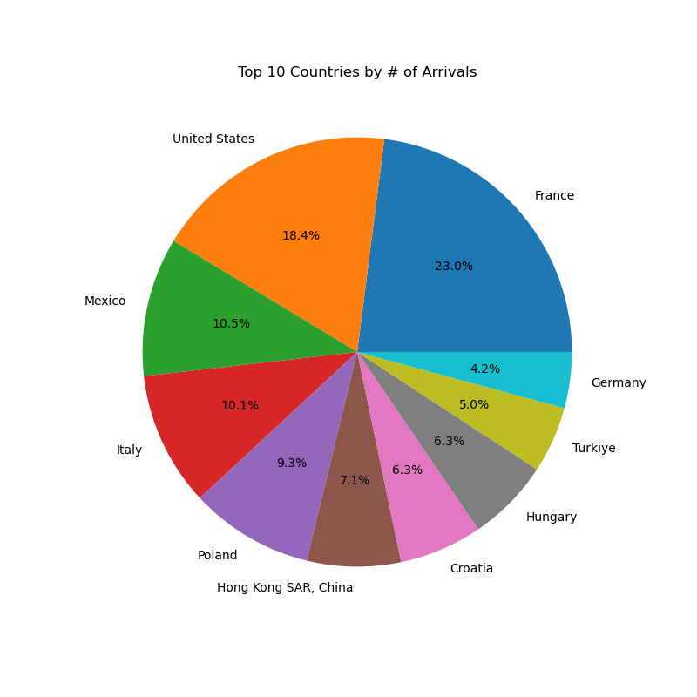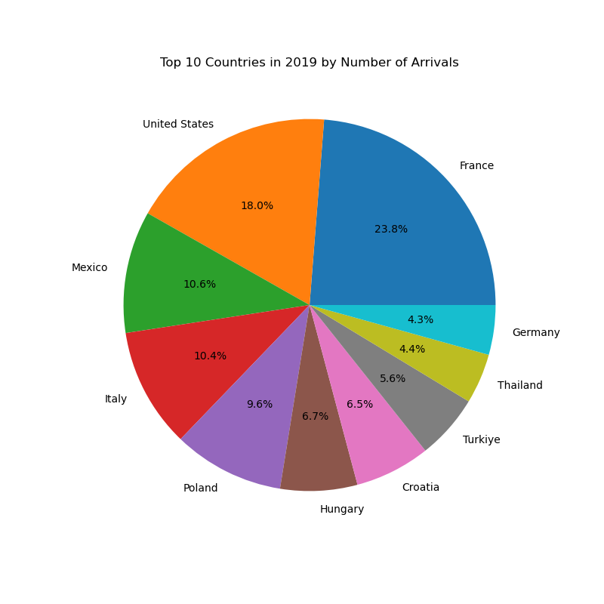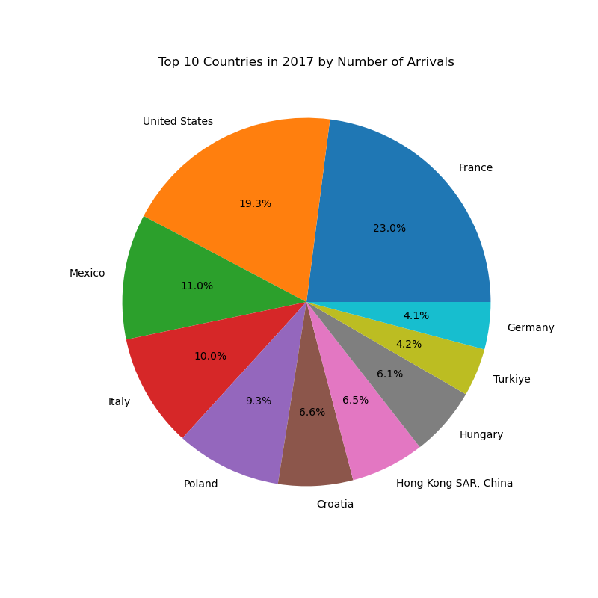

As seen by the pie charts, France consistently has the highest number of inbound tourists year over year. This should come as no surprise since it is home to one of the most famous cities in the world, Paris. Next, we needed to find if leading in the number of tourists also meant that country had the highest international tourism receipts or if these things did not have direct effects on each other.

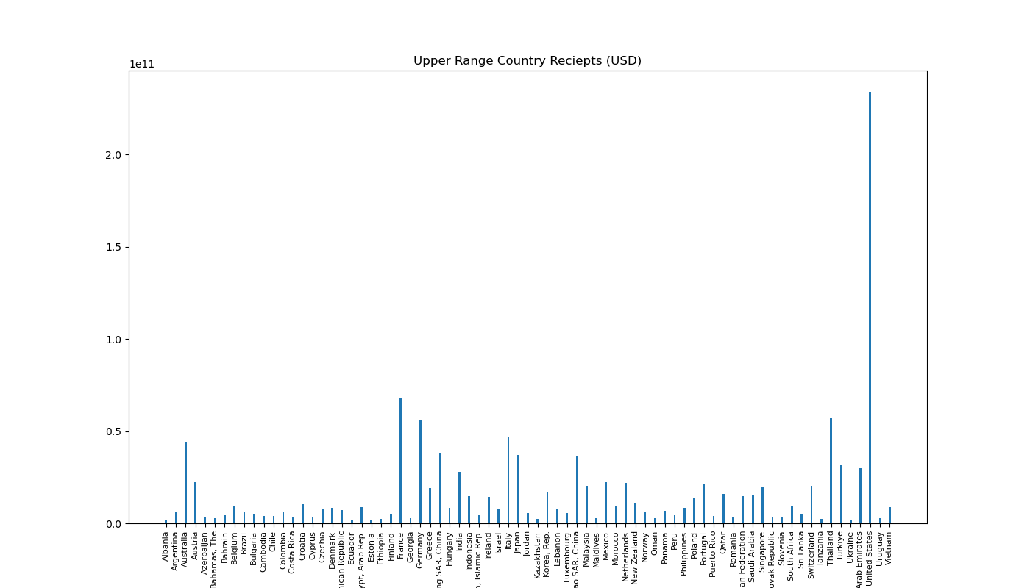Question 2: Which country had the highest tourism receipts?

Across all years that were analyzed the United States consistently had the highest count of international tourism receipts. With France trailing second at around sixty to seventy billion US dollars annually across all four years. The United States brought in around $230 billion to $240 billion annually. That’s just over 283 percent higher than France’s annual international tourism receipts. According to our analysis, leading in the number of annual tourists does not mean that the country will be leading in the amount of money brought in from tourism. This likely can be attributed to other factors such as the activities that a tourist might partake in or even time spent in that country.

Question 3: Which country had the highest GDP?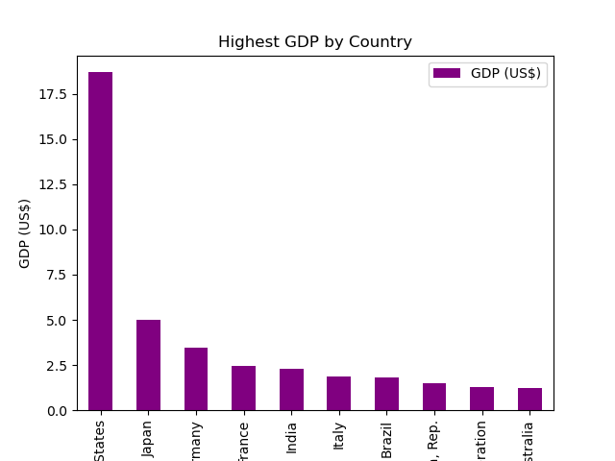

Next we decided to find which country had the highest GDP. We once again found the United States leading by a large margin. The USA floated around 18 trillion dollars a year in GDP while other countries sat well below a third of the USA’s annual GDP.

Question 4: What’s the correlation?

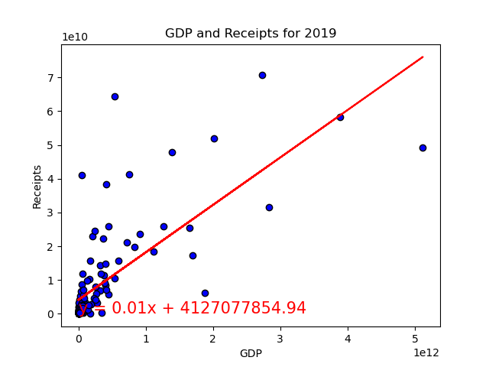

For our final question we looked at the correlation between GDP and tourism receipts. The purpose being to see the impact tourism might have on GDP and the results were promising. When looking across all four years the data shows a strong correlation. The r-value of all years ranged from .70 to .74. This doesn’t necessarily mean that high tourism receipts cause a high GDP but nonetheless the correlation is there.

Once we compared all our individual years, it was easy to recognize patterns of correlations. We found that the number of inbound tourists does not necessarily correlate to having the highest international tourism receipts. France is a constant leader in inbound tourists however, the United States beats France in international tourism receipts by a landslide. This data allowed us to conclude that the more people that are entering a country as tourists does not mean the more money that they are spending while they are there. One thing we could add to this data set in the future is to compare this finding to the cost of living and good in each country as well. When comparing GDP to international tourism receipts, we did see a correlation. The r-value was 0.70 when outliers were removed and was 0.93 when outliers were included, showing strong correlation. As the United States led in tourism receipts, they also led in highest GDP.

We can conclude from these findings that policy makers should focus more on improving tourist sites and experiences to encourage spending rather than just attracting tourists.